Software Requirements Specification
for
Library System
Version 1
Prepared by Wiktor Duniec
2026-03-12
Revision History
Name | Date | Reason for Changes | Version
Wiktor Duniec | 2026-03-12 | Initial version | V1
Wiktor Duniec | 2026-03-12 | Remove unnecessary implied architectural boundaries, introduce use case diagram | V2
Wiktor Duniec | 2026-04-29 | Correct a few errors, introduce class diagram | V3

1. Introduction
1.1. Purpose
The implementation of a digital library system, providing a unified interface to user information and remote borrowing, for both library users and staff.
1.2. Product Scope
The software provides storage for the status of registered library users; including relevant personal information, information about currently borrowed books, and any reservations made on-line or in person. The system grants the ability for a user to remotely inspect this data or place book reservations, as well as for staff to view and modify this information. The software integrates with physical library cards in the form of QR codes. The intention is for the staff front-end to be deployed in working spaces, allowing immediate and convenient access to relevant data about the client, shortening queue time; the remote reservation features likewise are intended to cut down on physical waiting time.
2. Overall Description
2.1. Product Perspective
This product is intended as a replacement for an existing, non-digitized system of managing customer information. This includes the phasing out and replacement of existing artifacts (for instance, previously issued library cards).
2.2. Product Features
- The storage of customer data
- Interface with a physical library card system, and provisions to allow the decommissioned one to be utilized
- The ability to view and modify user data by “in-the-field” library staff
- An Internet-accessible client front-end for the viewing of user data, as well as a limited set of actions (reservations, extensions)
2.3. User Classes and Characteristics
The two primary user classes are clients and staff. The client group further divides into people unwilling to use the Internet aspects of the service, and people wishing to utilize it. The primary class of user will be the former group of clients; as such, it is important that the deployment of the system does not challenge the expectations that the average library customer holds.
2.4. Operating Environment
The manner in which the system exposes staff access shall operate on x86 or x86-64 machines running Windows 7 or newer, with no guarantee of graphical acceleration. The system shall cooperate with an arbitrary amount of mobile cameras (“web-cams”) attached to staff-accessible machines, for QR code scanning purposes. Auxiliary components may be delegated to a remote machine, with an x86-64 architecture and an up-to-date installation of Ubuntu Server, possibly hosted in the cloud. The system shall allow for client access via the Internet, on any popular browser no older than 2018.
2.5. Design and Implementation Constraints
The hardware available to staff is generally low-power and cheap; at minimum, a copy of Windows 7 with 2GB of memory available, and minimal graphical acceleration. The staff software must provide a responsive experience despite these limitations.
2.6. Assumptions and Dependencies
The project depends on the understanding of the previously used library card format; in order to facilitate interoperability, the documentation for it must be known. Furthermore, the staff software depends on a functional camera being attached to the computer, and is expected to gracefully degrade if that is not the case.
3. System Features
3.1. The storage of customer data
The system shall provide a way to persist user data, including:
- basic personal information,
- online account details (e-mail, hashed password – if exists, session token and its expiry date),
- list of borrowed books (including the book’s ISBN classification number, the borrow date, and the expected return time, and a requested extension time, if it exists),
- list of placed reservations (including the book’s ISBN classification number, the reservation date, and whether the reservation has been confirmed by staff),
- the decommissioned library card identifier (if it exists),
- the current library card identifier (the data blob stored within the QR code).
The system shall provide the ability to access and modify stored data, intended for staff. It shall also provide the ability to access and modify said data through the Internet, with proper authentication and limitations. In terms of modification, the client may only be allowed to:
- place reservations,
- request extension of the return time of borrowed books,
- set their password, if it has not yet been so.
These restrictions must be enforced securely by the system.
3.2. Issuing of digital library cards
The system shall allow for digital library cards to be issued by staff. This involves gathering information from the client (personal information, as well as information that will be used to create the online account, including an e-mail address), optionally the identifier of a decommissioned library card, as well as the generation of a corresponding QR code, and a print-out, if a printer is available.
3.3. Interacting with user data
The system shall allow for user data to be viewed and modified by staff. Modification includes adding or removing borrowed books, marking reservations as fulfilled, and the removal of user accounts. The system shall facilitate conveniently locating the user information by allowing the digital library card QR code to be scanned via a web-cam, or through a common device like a mobile phone. It must also allow for the decommissioned library card format to be used to query a user. The system shall give staff an easily accessible overview of currently borrowed and reserved books.
3.4. Client permissions
The client access permission shall be mediated based on current account state. If the account password has not been assigned yet, the client must be limited to solely changing the password. If permitted, the client shall be allowed to view their own data, as well as place both reservation requests and borrow time extension requests.
4. System Features/Modules
5.1. The storage of customer data
FRQ-1.1: The system shall securely store the customer data in a database.
FRQ-1.2: Customer data shall include at least the first and last name, e-mail, optional hashed password, optional session token and its expiry date, a list of borrowed books (including the book’s ISBN classification number, the borrow date, and the expected return time, and a requested extension time, if it exists), a list of placed reservations (including the book’s ISBN classification number, the reservation date, and whether the reservation has been confirmed by staff), an optional decommissioned library card identifier, and the modern library card identifier.
5.2. Availability of stored customer data
FRQ-2.1: The system shall allow database access for two types of user; the client user and the staff user.
FRQ-2.2: Full read-and-write access shall be provided to the staff user.
FRQ-2.3: The responsibilities of the staff user and the client user shall be securely separated.
FRQ-2.4: Read access of a single account shall be provided to a client user upon authentication through the identity of said account.
FRQ-2.5: Authentication of a client user shall be performed as a test of a password delivered securely. If a password is not set, any password shall be accepted.
FRQ-2.6: A session system that allows client user authentication to be elided during a configurable period, within safety bounds, shall exist.
FRQ-2.7: Write access of an authenticated client user shall be limited to adding an unconfirmed reservation and setting a requested extension time for an existing borrowed book.
FRQ-2.8: The client user shall not be allowed any action beyond establishing a session, if one does not currently exist.
FRQ-2.9: In the case when a session exists but a password is not set, the client user must not be allowed any action beyond ending the session and setting the password in a separate interface.
5.3. Issuing of digital library cards and account management
FRQ-3.1: The staff user shall be provided a separate interface for customer account creation.
FRQ-3.2: The customer account creation interface shall provide a way to manually input all user information required for account configuration, as conforming to FRQ-1.2, with the exception of the password hash, session token, session token expiration time, and modern library card identifier, which shall be left empty.
FRQ-3.3: The modern library card identifier shall be automatically generated using a secure algorithm during account creation.
FRQ-3.4: Upon account creation, the system shall send a QR code of the modern library card identifier to the customer via the provided e-mail.
FRQ-3.5: If a printer is available, the system shall provide an option to print the QR code specified in FRQ-3.4.
5.4. Interacting with user data
FRQ-4.1: The staff user shall be provided a separate interface for the viewing and modification of customer data.
FRQ-4.2: The interface specified in FRQ-4.1 shall allow for discovering a user account via a decommissioned library card code.
FRQ-4.3: The interface specified in FRQ-4.1 shall allow for finding a user account via a modern library card code, in the form of either manual text input or a QR code scanned through a video input available to the staff user.
FRQ-4.4: Any data specified in FRQ-3.2 shall be possible to view and modify through the interface specified in FRQ-4.1.
FRQ-4.5: The system shall not allow a book to be borrowed by two users at the same time.
FRQ-4.6: The staff user shall be provided a separate interface for aggregated global information.
FRQ-4.7: The aggregated global information displayed in the interface specified in FRQ-4.6 shall include a list of currently-borrowed books and a list of currently-reserved books, alongside the users responsible for these states.
5.5. Client user interface
FRQ-5.1: Establishing a client user session involves a separate interface that allows the input of an e-mail and password.
FRQ-5.2: If a client user session exists, the user shall be provided a separate interface for viewing their data.
FRQ-5.3: If a client user session exists, the user shall be provided a separate interface for adding an unconfirmed reservation for a book via its ISBN classification number, as well as setting a requested extension time on an existing book.
FRQ-5.4: Any changes shall be synchronized immediately after client user interaction.
FRQ-5.5: The client user shall be notified of a synchronization failure after no more than 5 seconds.
6. Nonfunctional Requirements
6.1. Performance
NF-1.1: Every user interaction of the staff software, subtracting the time spent waiting for network operation, shall not take any longer than 1 second.
NF-1.2: Every back-end operation shall not take any longer than 1 second.
NF-1.3: Every user interaction of the client web-app, subtracting the time spent waiting for network operation, shall not take any longer than 500 milliseconds. This will likely necessitate the usage of a client-side, JavaScript framework.
Appendix A. Use Case Diagram
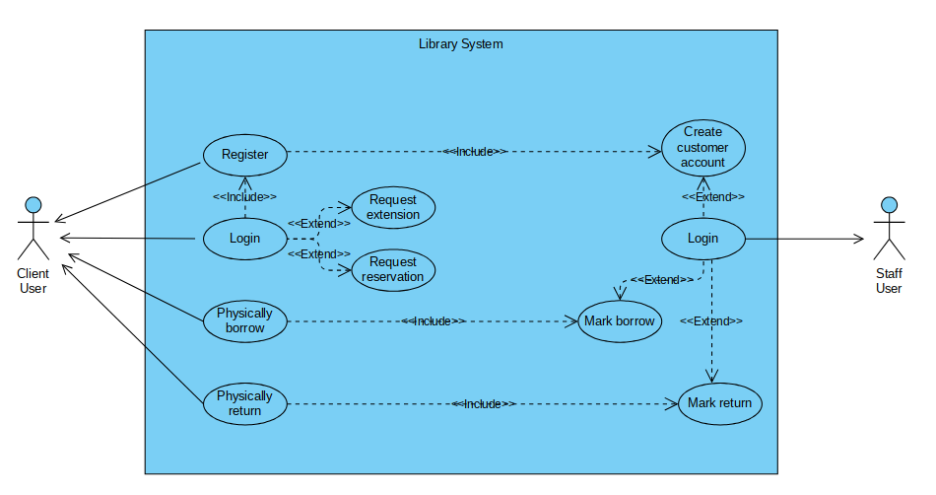
Appendix B. Class Diagram
